Adam Jarvis Assignment 1

For this assignment, I utilized OSC and Numba to test and demonstrate parallel speed up on a computational demanding application. In this Assignment, we generate the Mandelbrot set using Python.

Below is the starter code:

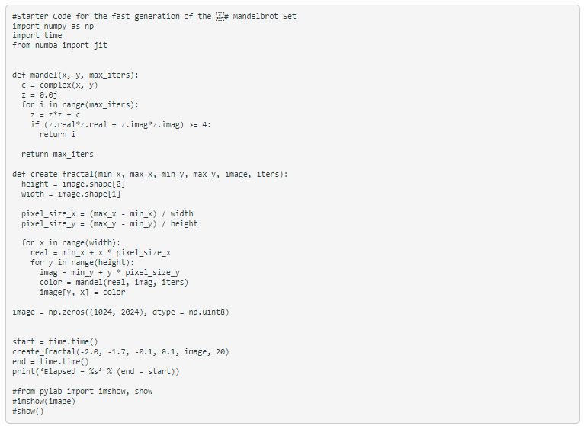

After running the starter code, the following result is outputted to the terminal:

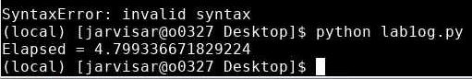

As displayed above, the elapsed time using the starter code is 4.799 seconds. However, after implementing the “numba” package using conda, I edited the code to show elapsed time with compilation and after compilation. See code below:

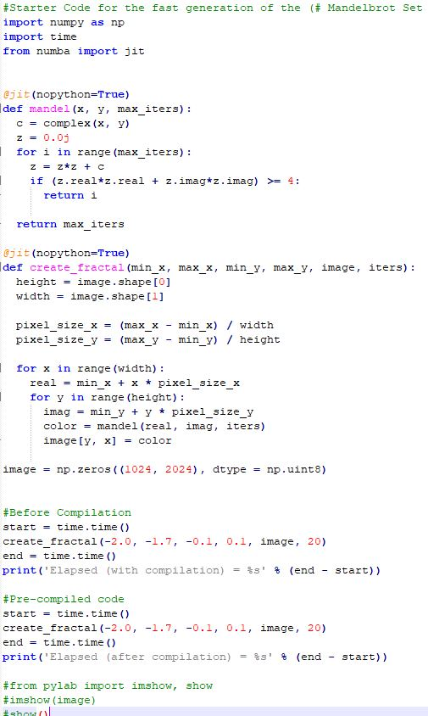

Using the code above, the following result is outputted to the terminal: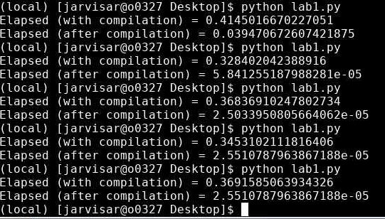

I ran my code several times to see how the results change between attempts. On average, the elapsed time with compilation takes around 0.3 to 0.4 seconds, while elapsed time after compilation is incredibly fast, with an average around 0.00002 seconds to 0.00005 seconds. In fact, the terminal must resort to scientific notation to display the elapsed.

All in all, the starter code above took around 4 to 5 seconds on average. However, the modified code using numba and jit has an average elapsed time of 0.3 to 0.4 seconds (with compilation) and around 0.00002 and 0.00005 seconds after compilation.